**Cutting File Vertically**

**Cut -c “initial” – “final” filename**

**  
cutting vertically from backside. “–“ sign after number**

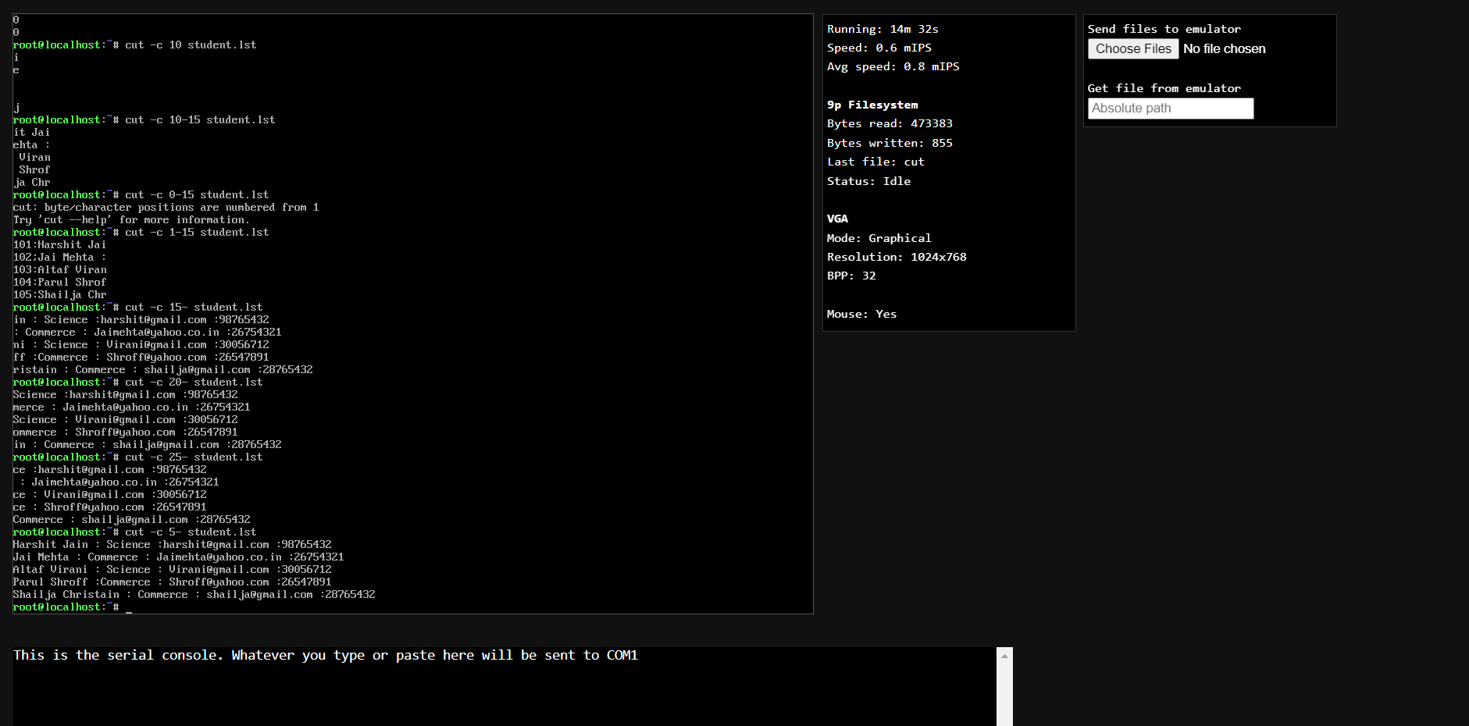

**Cutting Fields(-f)**

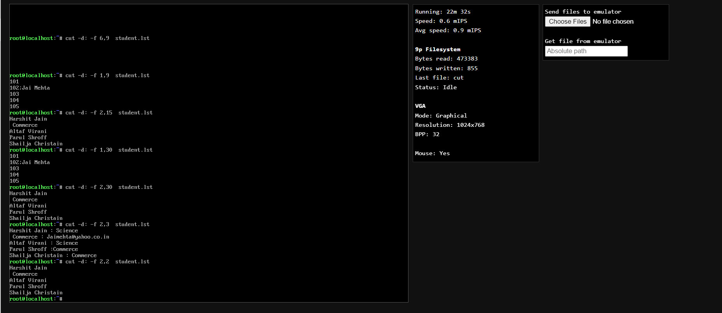

**File cutting and creating new file**

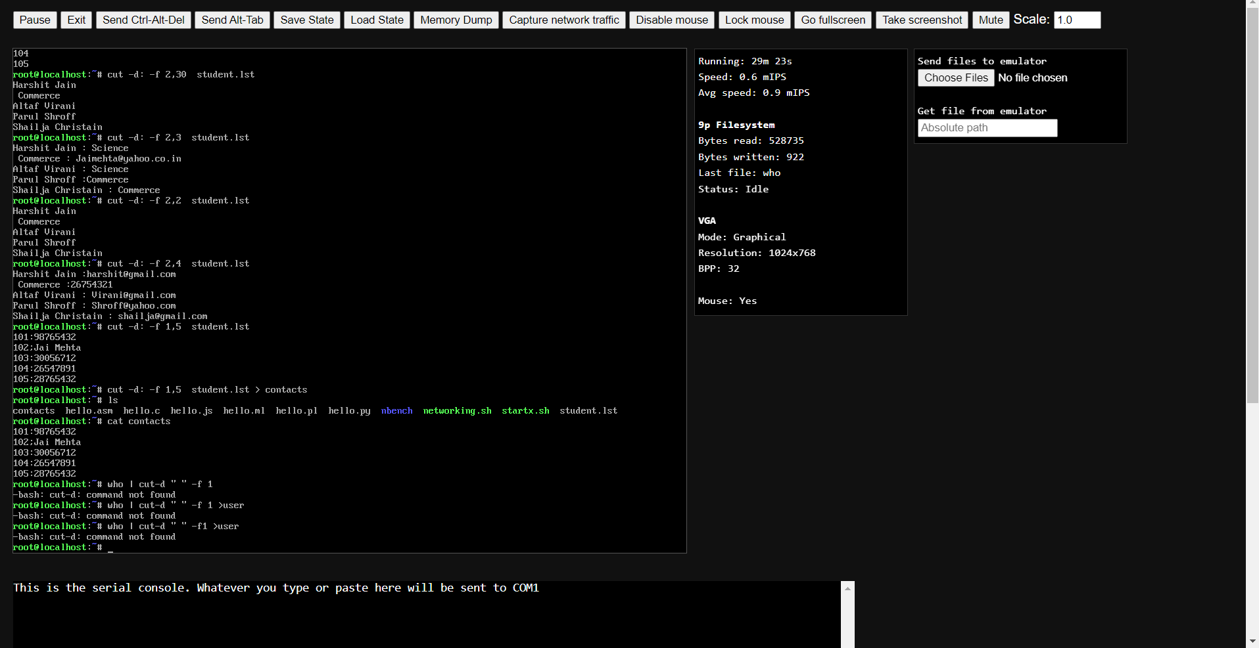

**Pasting Files**

**$Paste steam contact**

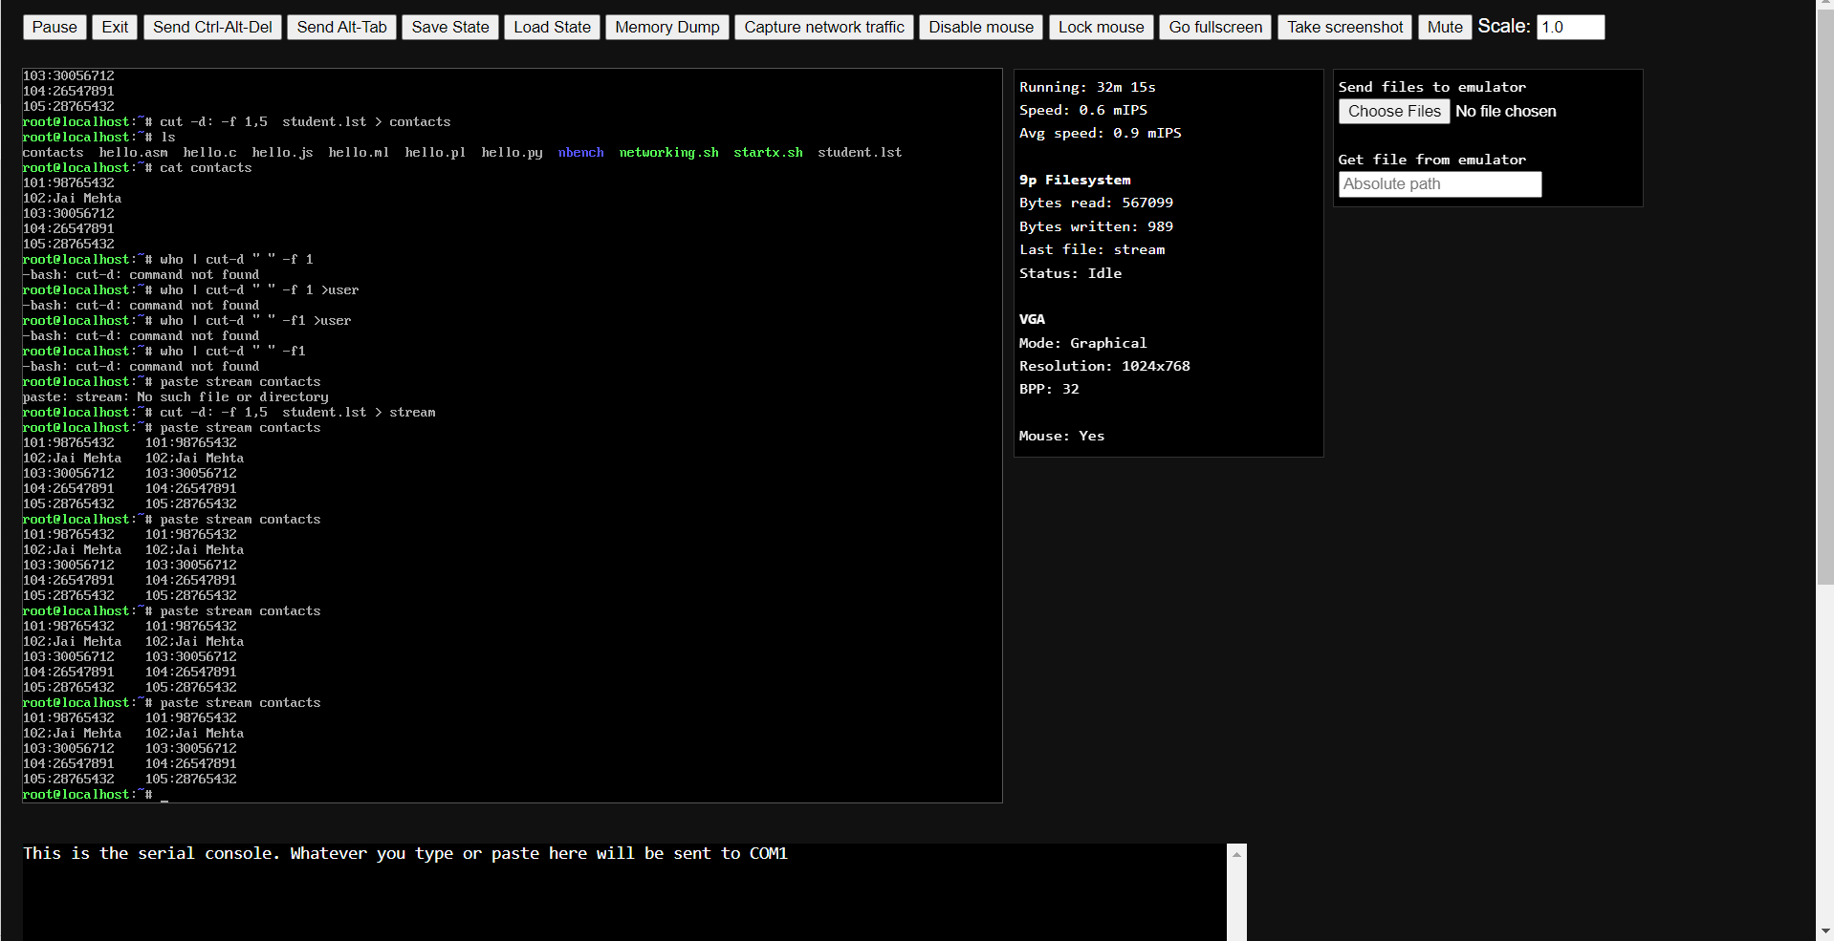

**Sorting file**

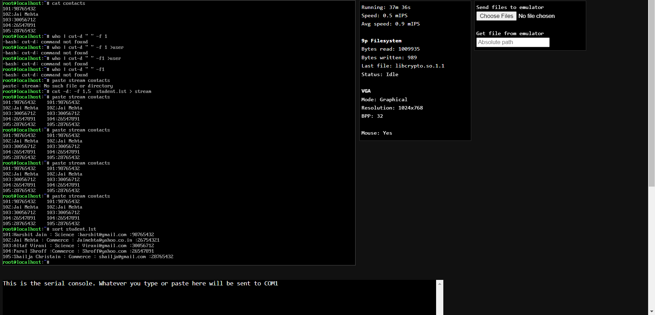

**To display items in file in Reverse Order**

**Sort -r student.lst**

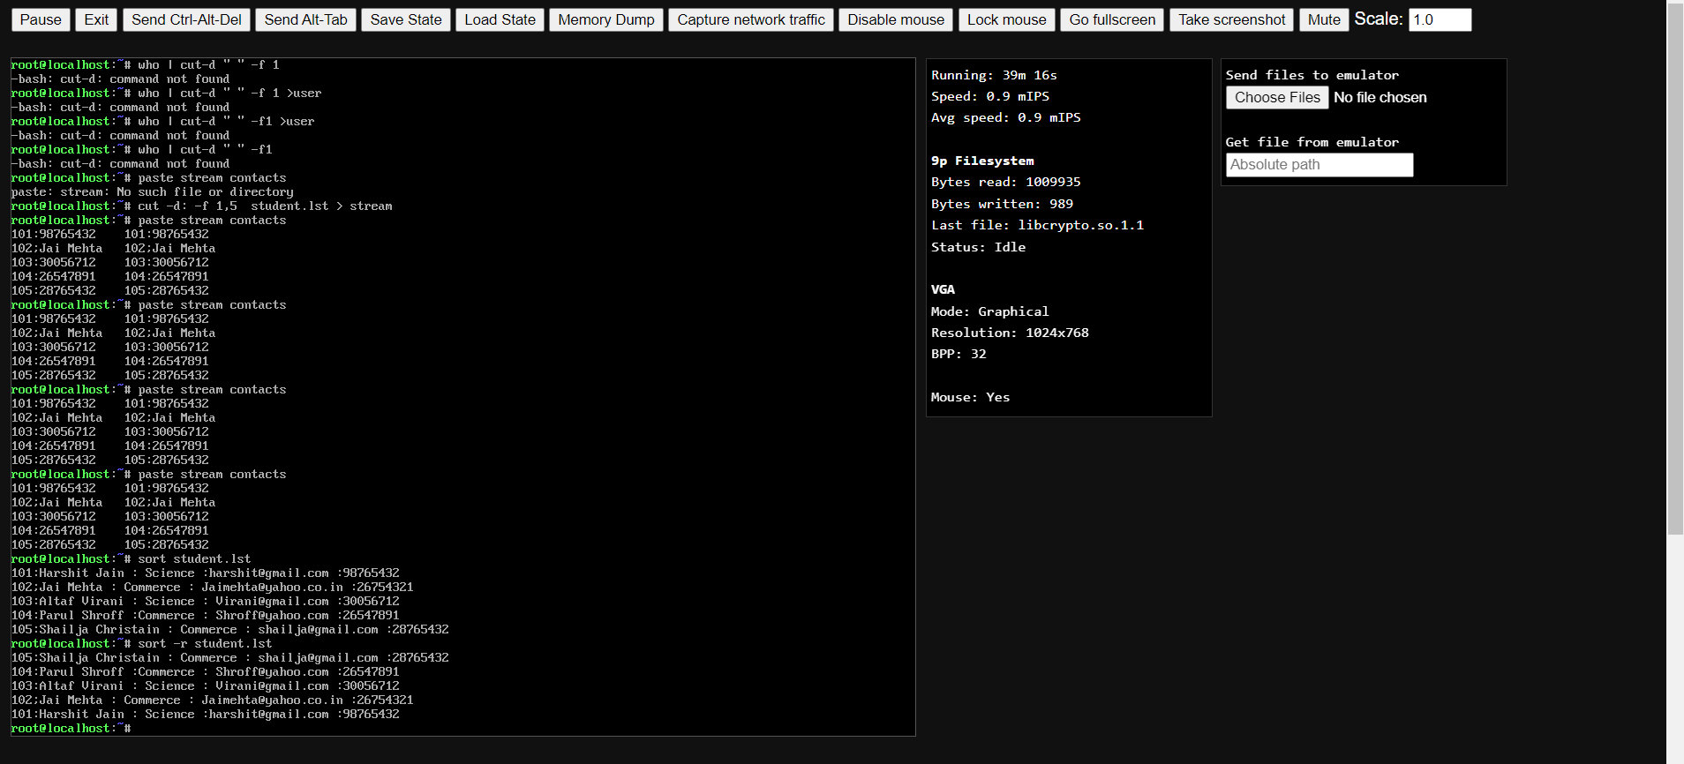

**To sort and to cut the file**

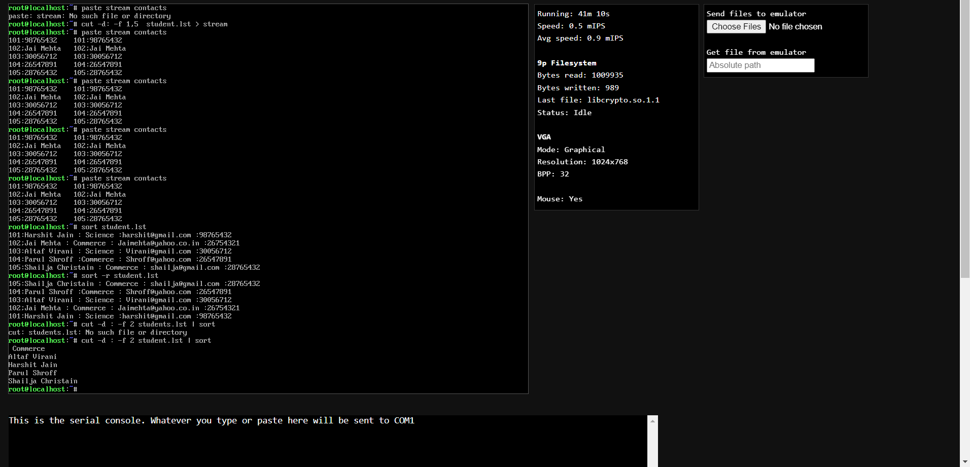

**Locate Unique Lines From The File**

**Ls -l | cut -d : -f 2,3 | uniq | sort**

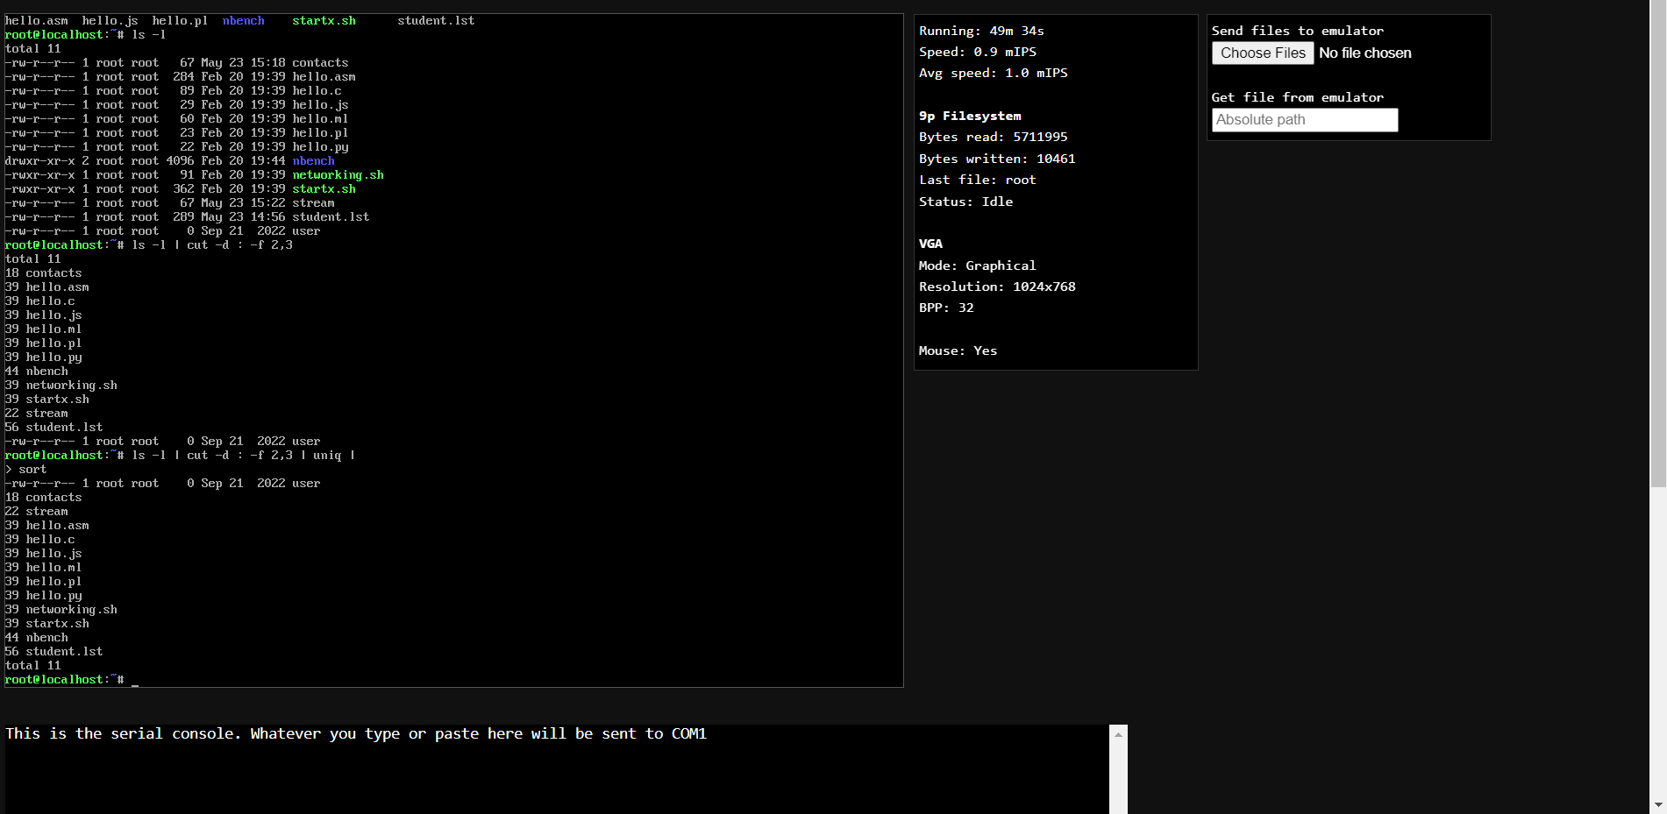

**Translating Characters**

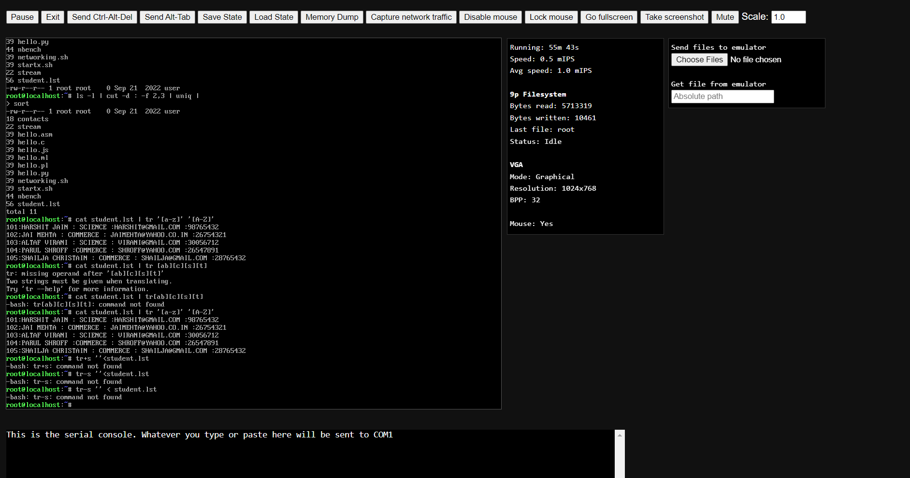**Saving file after changing characters**

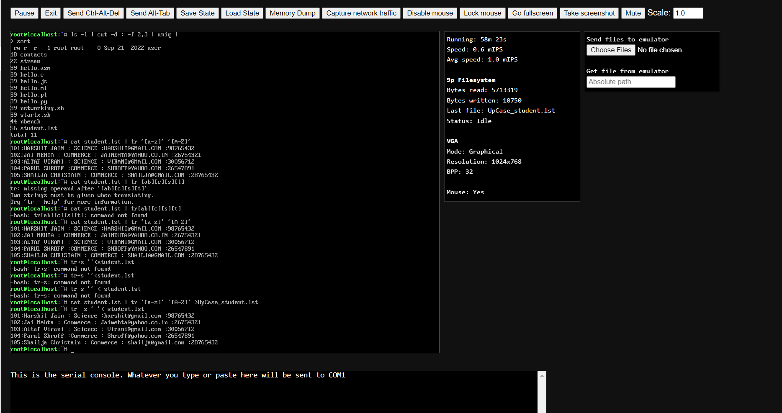

**Compressing Files**

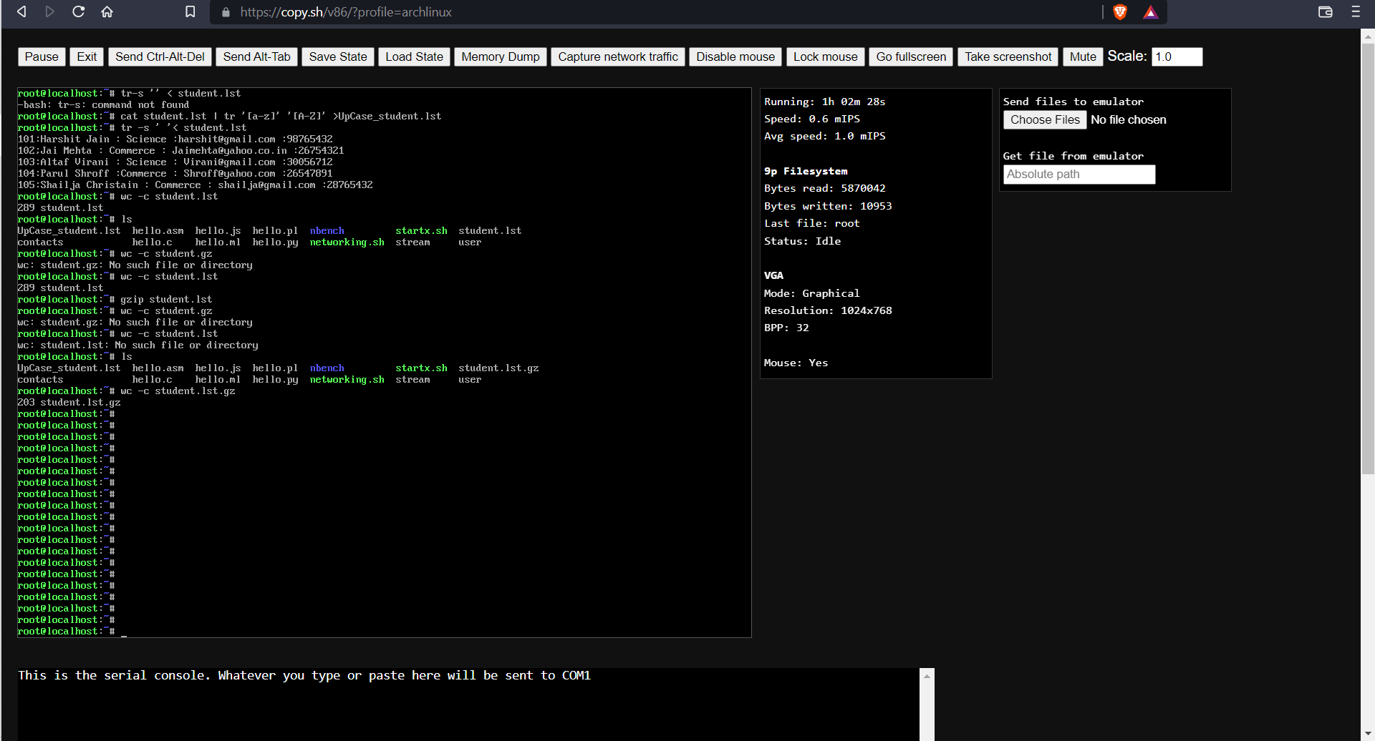

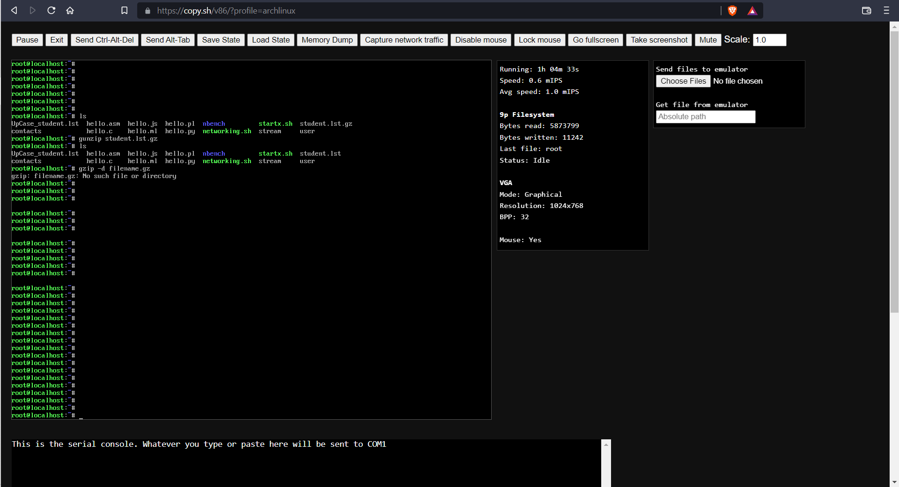 **Decompressing Files**